Lab Assignment 10
Stepan Shkrobak
Dr. Michael Bartolacci
IST 894, Section 001: Capstone Experience,
5 April 2026

Table of Contents

Table of Contents 1
General Context 2
Technical Context 3
Screenshots 5
References 11

General Context
The Digital Forensic Techniques lab focused on general skills in collecting, examining, and preserving network evidence. The lab emphasized packet capture and protocol analysis, including the use of forensic tools to review network communications, isolate meaningful traffic patterns, and identify cases where credentials or system details were transmitted in cleartext. It also introduced evidence preservation concepts by emphasizing that collected data must be handled in a way that maintains integrity and supports later review or legal use. That overall approach aligns closely with NIST guidance that organizations should integrate forensic collection and analysis into incident response so evidence can support both technical investigation and decision-making.
The lab also involved examining network conversations, identifying insecure services, recognizing how a weak protocol can expose system details, and determining whether authentication-related data could be observed by an unauthorized party. It covered validating evidence through hashing so that a traffic capture can later be shown to be unchanged from the moment it was collected.
The Indicators of Compromise lab focused on investigating a host. It focused on recognizing the warning signs that a Linux system had been compromised and then assessing how an attacker maintained access (Scarfone & Mell, 2007). First, identify a file that stood out as abnormal, and then further investigate for unusual administrator activity, suspicious processes, abnormal listening ports, questionable scheduled tasks, and signs of data movement or remote access that should not normally be present. It also addressed persistence, meaning the methods an attacker uses to ensure access continues even if one malicious process is discovered and stopped. CISA describes indicators of compromise as the clues responders use to detect, diagnose, halt, and remediate malicious activity, which is exactly the type of work this lab was simulating.
During the investigation, the abnormal file was analyzed to determine that it was a backdoor script used to open a network port and allow remote command execution on the system. The lab then involved identifying and removing the cron job that repeatedly executed the script, terminating the malicious process, cleaning up unauthorized SSH key locations in the configuration, and verifying through process monitoring that the backdoor was no longer running.

Technical Context
The Digital Forensics Techniques lab focused on capturing, analyzing, and preserving network-based evidence. Live traffic is captured using the command tcpdump, which saves traffic from a network interface into a packet capture file that allows for later review. The command used was sudo timeout 20 tcpdump -i ens32 -w /home/ubuntu-user/data.pcap, which output data.pcap, allowing us to then use Wireshark to analyze the pcap file. Using some filters like tcp.port ==23 and tcp contains login, we were able to identify Telnet traffic and find authentication data. This allowed us to then examine insecure communications, identify cleartext exposure of system details and credentials, and follow TCP streams to verify whether unauthorized authentication had succeeded (Wireshark Foundation, 2024). The lab also covered forensic integrity validation by generating hashes of the captured evidence, using commands such as md5sum /home/ubuntu-user/data.pcap and shasum /home/ubuntu-user/data.pcap, so the packet capture could later be verified as unchanged from the time it was collected. According to the National Institute of Standards and Technology (NIST), digital forensic techniques such as traffic capture and hashing are commonly integrated into incident response processes so investigators can preserve evidence and verify that collected data has not been altered during analysis (NIST SP 800-86).

The Indicators of Compromise lab focused on host-based compromise analysis and response on a Linux system. The investigation began by reviewing the filesystem for suspicious content with commands such as ls -al and ls -lt /, which helped identify an abnormal file named backdoor.sh. That file was then examined with cat /backdoor.sh, revealing that it was being used to open a port and spawn a shell for remote access. Network and process inspection were then used to identify attacker activity and persistence, including netstat -lntp to view listening ports and associated processes, ps -aux | grep cron to identify cron-related activity, and crontab -l to confirm that a malicious scheduled task was being used to repeatedly execute the backdoor (SANS Institute, 2023). As noted in the SANS Institute’s incident response guidance, analysts frequently examine running processes, network connections, and scheduled tasks because these artifacts often reveal how attackers maintain persistence on compromised Linux systems. The lab also involved checking remote access activity with commands such as w, monitoring live network usage with iftop -n -i ens32, and inspecting SSH-related files and configuration, including ls /home/ubuntu-user/.ssh/ and reviewing /etc/ssh/sshd_config, to determine whether hidden authentication paths had been added for persistence.
The lab finally covered containment and remediation without fully rebuilding the system. This included removing the malicious scheduled task, terminating the attacker’s active process with pkill ncat, deleting the backdoor using rm /backdoor.sh, temporarily stopping SSH with service ssh stop, correcting unauthorized SSH configuration changes in /etc/ssh/sshd_config, removing the hidden key directory with rm -rf /home/ubuntu-user/.secret/, and then restarting the service with service ssh start. The final verification step used ps -aux and continued observation of system behavior to confirm that the malicious process had been eliminated and that the persistence mechanism no longer reappeared.

Screenshots
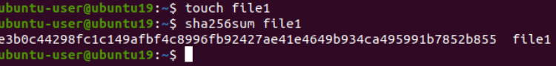
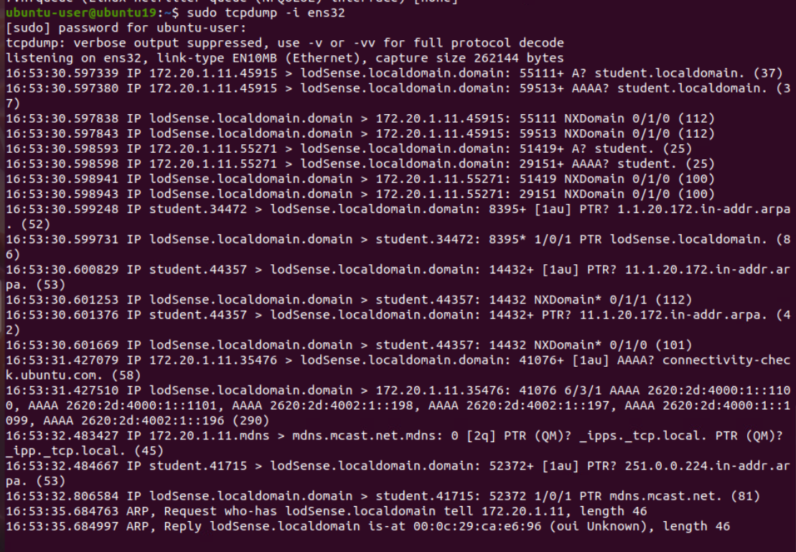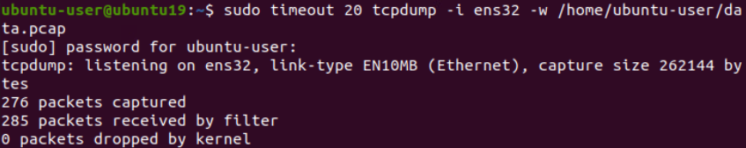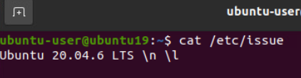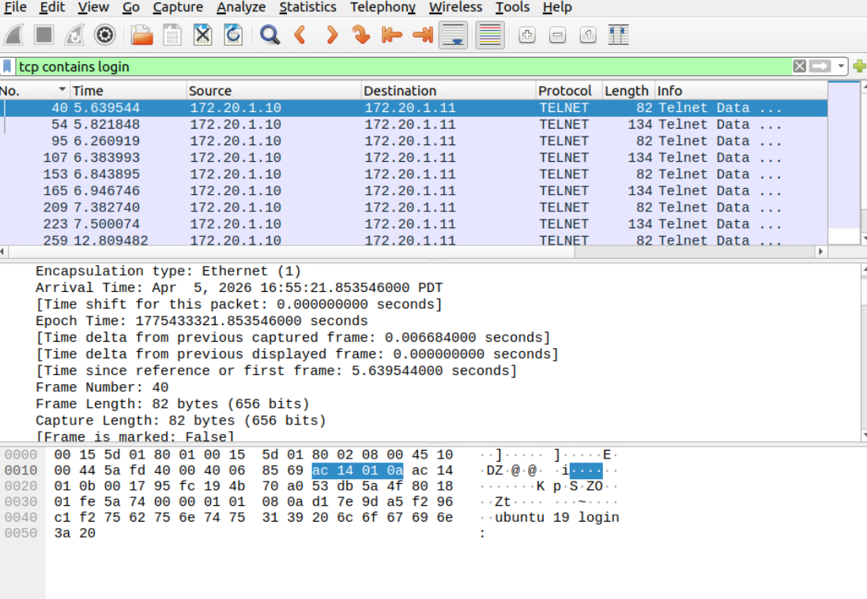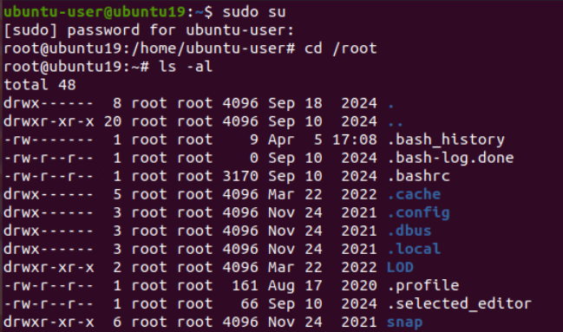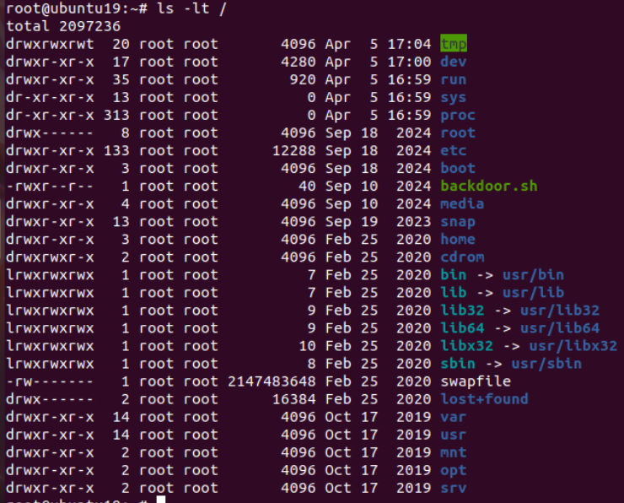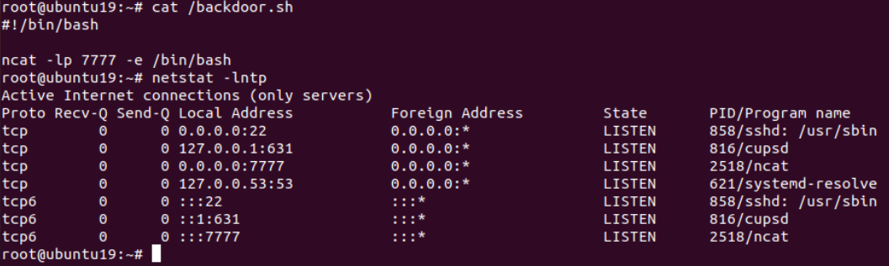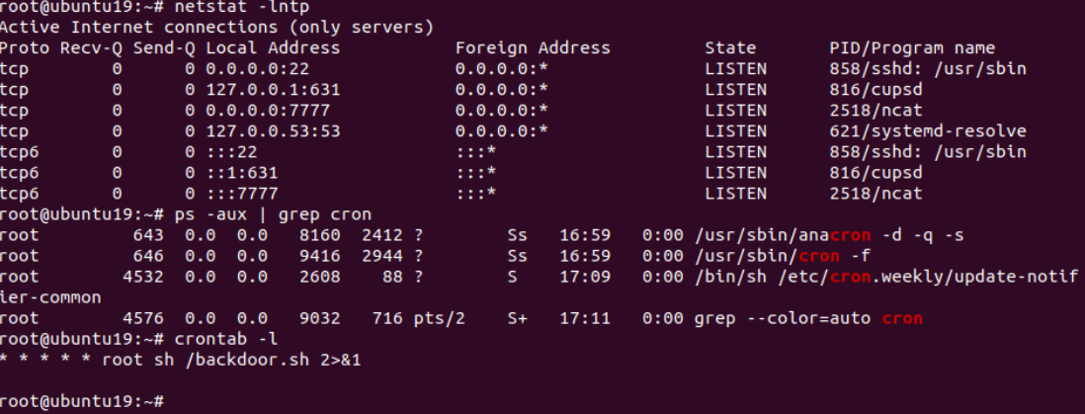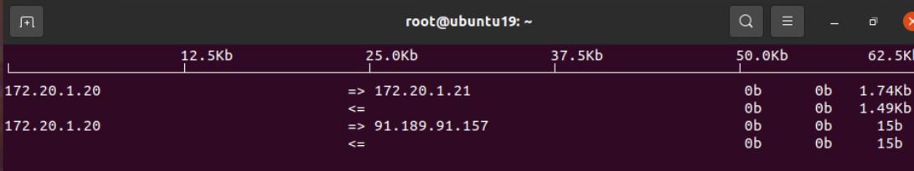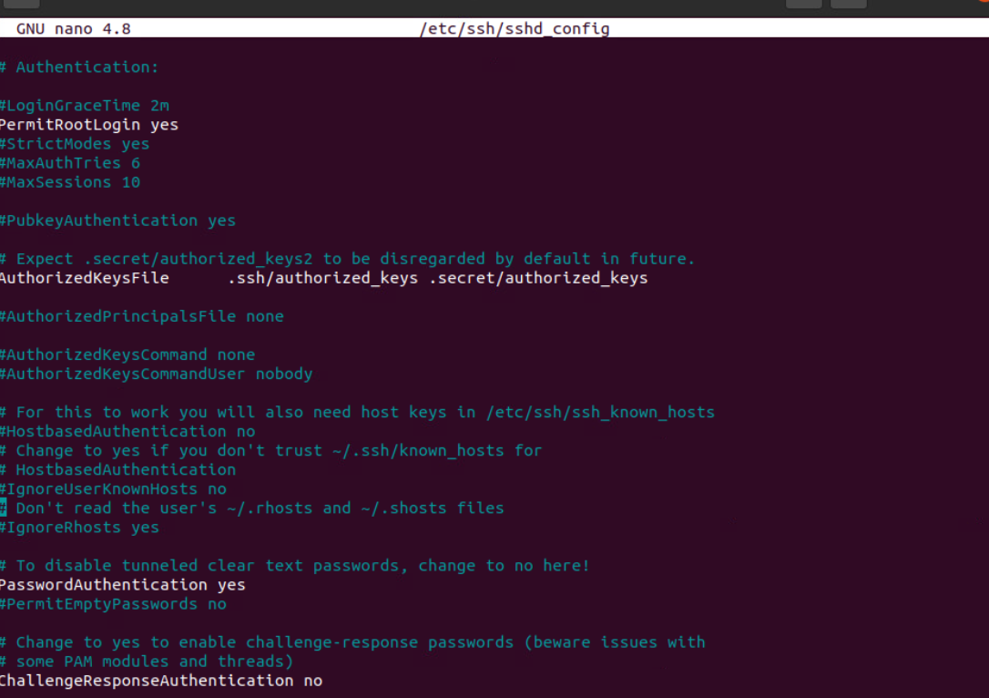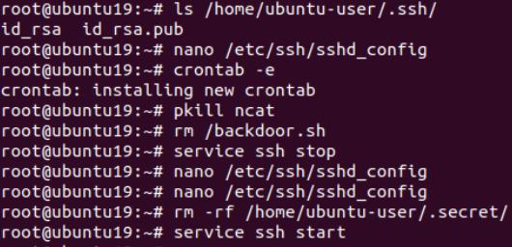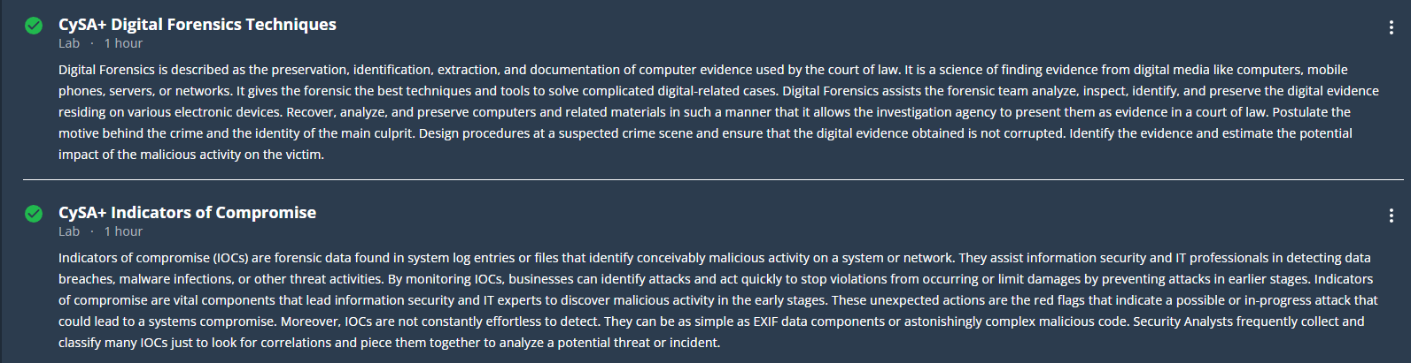

References
National Institute of Standards and Technology. (2006). Guide to integrating forensic techniques into incident response (Special Publication 800-86). U.S. Department of Commerce. https://nvlpubs.nist.gov/nistpubs/Legacy/SP/nistspecialpublication800-86.pdf
National Institute of Standards and Technology. (2007). Guide to intrusion detection and prevention systems (IDPS) (Special Publication 800-94). https://nvlpubs.nist.gov/nistpubs/Legacy/SP/nistspecialpublication800-94.pdf

SANS Institute. (2023). Incident handler’s handbook. https://www.sans.org/white-papers/33901/
Wireshark Foundation. (2024). Wireshark user’s guide. https://www.wireshark.org/docs/wsug_html/

